An Introduction to Linear Algebra Using Python

Dr. Steven L. Richardson
Howard University and Harvard University
Tuesdays 2:00 p.m. – 3:35 p.m. (Zoom Lecture)
Tuesdays 3:35 p.m. – 4:30 p.m. (Zoom Recitation Session)
srichards22@comcast.net

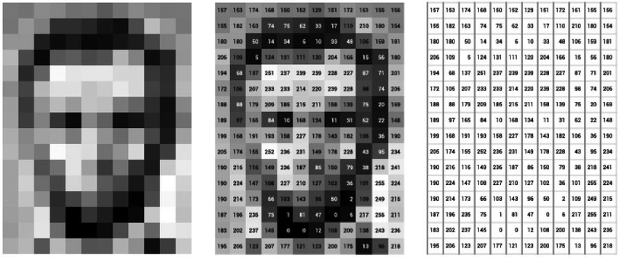
This photo of Abraham Lincoln can be represented as a matrix of pixels or numbers.

Linear algebra is an invaluable tool which serves as the gateway to a number of important subjects such as scientific computing, machine learning, quantum computing, and computer graphics. In this course we will cover the following topics: how to simultaneously solve systems of linear equations using determinants, Cramer’s rule, the method of cofactors and minors, Gauss-Jordan elimination, properties of matrices, the inverse of a matrix, using Gauss-Jordan elimination to find the inverse of a matrix, the rank of a matrix, review of vector analysis, expressing vectors as matrices, the basis of a vector, the linear dependence and independence of vectors, orthogonal and orthonormal vectors, the inner product of vectors, complex vectors and their inner products, special types of matrices (e.g. orthogonal, unitary, and Hermitian), linear transformations, the eigenvalue problem, matrix diagonalization, and the least squares approximation in linear algebra. NumPy (a numerical library of Python) is a very convenient package which is used to code both vectors and matrices and we will use some simple applications of it throughout this course to reinforce the important concepts and examples of linear algebra. We will assume throughout this course that the student is neither fluent in linear algebra nor Python.

This course is supported by the National Science Foundation Science and Technology Center for Integrated Quantum Materials, NSF Grant No. DMR-1231319

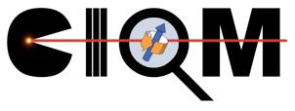
Lecture 1 (Tuesday, May 18, 2021): How to simultaneously solve systems of linear equations using determinants, Cramer’s rule, and an introduction to the method of cofactors and minors

Lecture 2 (Tuesday, May 25, 2021): The method of cofactors and minors and an introduction to Gauss-Jordan elimination

Lecture 3 (Tuesday, June 1, 2021): Gauss-Jordan elimination and the properties of matrices

Lecture 4 (Tuesday, June 8, 2021): The inverse of a matrix and how to use Gauss-Jordan elimination to find the inverse of a matrix

Lecture 5 (Tuesday, June 15, 2021): The rank of a matrix and how to use it to simultaneously solve systems of linear equations

Lecture 6 (Tuesday, June 22, 2021): Review of vector analysis: vectors in one, two, and three dimensions, scalar multiplication of vectors and vector addition, linear combination of vectors, the dot product of vectors, the linear dependence and independence of vectors, and viewing vectors as matrices (Part I)

Lecture 7 (Tuesday, June 29, 2021): Viewing vectors as matrices (Part II), the norm of a vector, the standard basis of a vector, orthogonal and orthonormal vectors, using basis vectors to span R¹, R², and R³, and viewing systems of linear equations through the equation Ax = b (Part I)

Lecture 8 (Tuesday, July 6, 2021): Viewing systems of linear equations through the equation Ax = b (Part II), matrix multiplication revisited, beyond three dimensions: vectors in R^{n}, complex numbers, and the inner product of vectors (Part I)

Lecture 9 (Tuesday, July 13, 2021): The inner product of vectors (Part II), complex scalars and complex vectors, and realizing that matrices can do things: viewing matrices as operators

Lecture 10 (Tuesday, July 20, 2021): The change in basis problem and the eigenvalue problem (Part I)

Lecture 11 (Tuesday, July 27, 2021): The eigenvalue problem (Part II) and diagonalizing matrices (Part I)

Lecture 12 (Tuesday, August 3, 2021): Diagonalizing matrices (Part II) and the least squares approximation in linear algebra (Part I)

Lecture 13 (Tuesday, August 10, 2021): The least squares approximation in linear algebra (Part II)

